Mia Olson

AP CSP

Notes Summary Questions

1. **For each of these letters, tell us both what the hardware component is called and what it's used for.**

Letter A is the CPU Socket and it is responsible for performing the logic of the software programs. It is the brain of the computer. Letter B is the DIMM Memory Slots and they attach the RAM (random-access memory) to the motherboard. Letter C are the PCI Slot and it connects the graphics card to the motherboard. Letter D is the SATA Connector and it connects the computer’s hard drive to the motherboard so that all of the data can be accessed on that computer. Letter E is the CMOS Backup Battery and its job is to store a small bit of information that is used by the BIOS to begin the startup process, such as the time and date. Letter F is the 24-pin ATX Power Connector and connects the power supply with the motherboard as well as circulates air throughout the computer to prevent overheating. Letter G is the IDE Connector and it also connects the computer’s hard drive to the motherboard.

1. **In a succinct paragraph, what *does* happen when you turn on your computer?**

When you turn on your computer, the first thing that happens is that a signal is sent to your power supply from pressing the power button. This manages the electric voltage that it sent to they parts of the computer. Then, the BIOS starts up. The BIOS first reads the settings from the CMOS and checks if the computer’s video card works. Next, the BIOS performs some power on self tests (POSTS) that check if the random-access memory (RAM) is readable and writeable. The POSTS then check for any plugged in devices, such as a mouse or keyboard, and once it is completed, the BIOS starts loading the operating system on the computer. Lastly, the BIOS displays text that shows you how to change the settings as the computer boots up.

1. **Take some time to get to know your computer a little better, and let us know of the following:  a. Brand and model  b. Hard drive capacity  c. Amount of RAM  d. Type of CPU  e. Display resolution and size  f. Operating system**

My computer is a MacBook Pro Model A1398 with a hard drive capacity of 1 terabyte. The amount of RAM is eight gigabytes and the type of CPU is an Intel Core i7. The display resolution is 2880 x 1800 and it is a 15-inch laptop. Lastly, the operating system is the macOS Sierra – 10.12.6.

1. **Now, take a look at the various ports on your computer. For each of your computer's ports, give us a picture or sketch as well as a description of what the port is called and what can plug into it.**

Port A is known as the power port where the charger for the laptop can be plugged in to power up the computer. Ports B and C are known as thunderbolt ports. They can be used to connect a larger display or screen to the laptop. Ports D and H are called USB ports. They are used to plug in USB cable to the laptop that can connect other devices such as a mouse or a phone. Port E is a headphone jack where a headphone or speaker chord can be plugged in to access the sound. Port F is an SDXC card slot where it allows the laptop to read SD, SDXC, and SDHC cards that are used in cameras. Lastly, Port G is an HDMI cable slot that is often used for connecting a laptop to a TV.

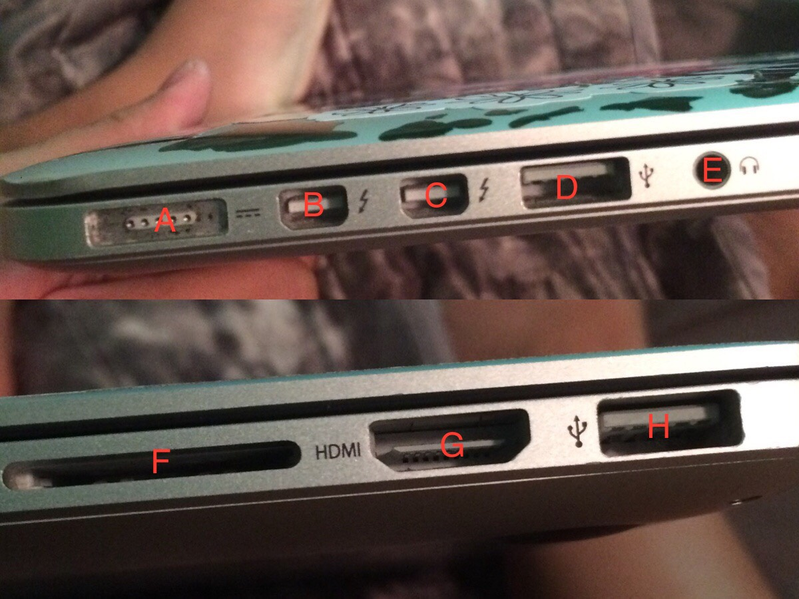

1. **Now, try poking around the BIOS menu for your computer. In a short paragraph, describe what you find.**

The MacBook I currently have does not have a BIOS. Instead, it has an EFI. The EFI menu contains a list of hard disks found with the computer. There is also a line that says, “press any key to continue…” and has a list of directories of the computer.

1. **Your friend just came home with a brand new printer from Better Buy, but unfortunately, there wasn't any kind of cable in the box! What exactly does your friend need to buy in order to use his new purchase?**

My friend needs to buy the cable that is used for that particular printer, which in most cases is a USB chord. Without the cable, my friend either will not be able to turn it on or they will not be able to plug it in to a computer to use it.

1. **I just purchased a new computer monitor with only a DVI port. Sadly, my laptop only has a slot for an HDMI cable. Am I out of luck? My sister's laptop, on the other hand, has a slot for a VGA cable, should I just give the monitor to her?**

You are not out of luck because you can buy a chord with an HDMI plug on one end and a DVI plug on the other end. Therefore, you can use that chord to connect your computer to the monitor.

1. **So, should you spend $250 on an HDMI cable?**

You should not spend all that money on a cable because there are plenty of other HTMI cables that are cheap and work just as well as the cable that is $250.